**11-User Rights Assignment :**

1. run🡪gpedit🡪 COMPUTER CONF > WINDOWS SETTING> SEC SETTING > 🡪Local Policies🡪

user rights assignment🡪shut down the system Or login locally or Login from network

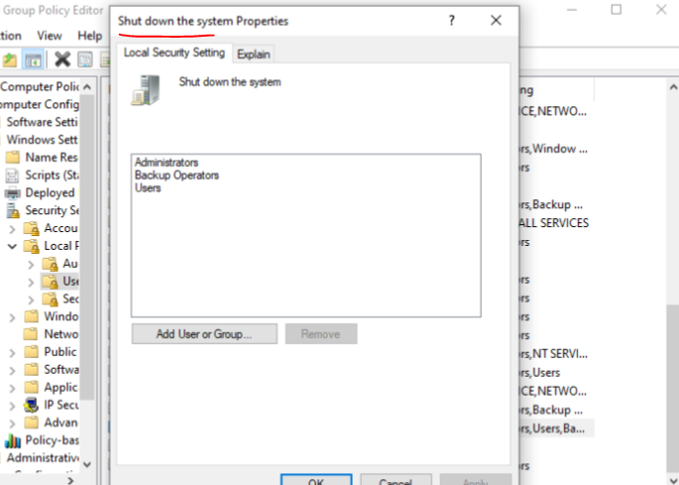

**12-Security options polocies :** 1. run🡪gpedit🡪 COMPUTER CONF > WINDOWS SETTING> SEC SETTING > 🡪Local Policies🡪

Security Options🡪shut down the system: allow system to be shut down without having to login

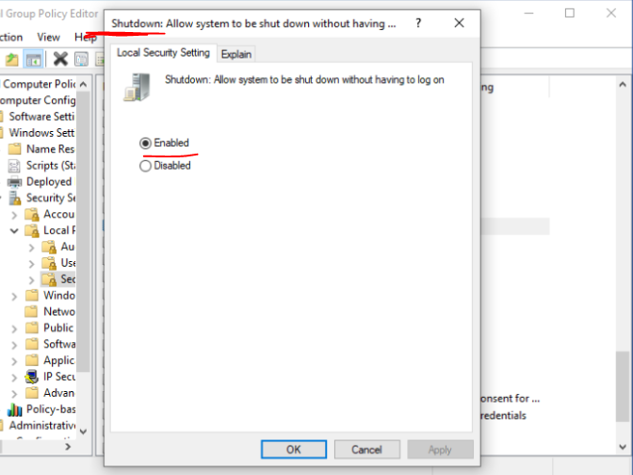

**13-Windows Remote Assistant:**

1-Start menu🡪 help and support🡪Use windows Remote Assistant🡪Invite someone to help me🡪Set invitation password🡪choose your way to send Invitation

* Asmaa asked (the second VM) to help her remotely

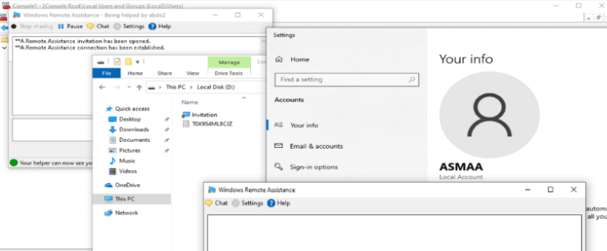

**14-Windows Remote Desktop:**

Connect remotely from your first VM pc to the second VM pc and take the first HD pc with your connection.

* Asmaa connected remotely to her PC from ( the second VM) and take Volume D: on this local pc with her.

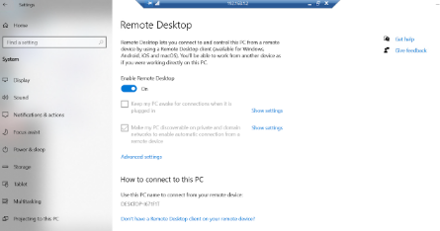

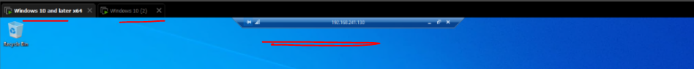**15- Remote Desktop third party program:**

* Use third party program like any disk or team viewer
* By using team viewer program try to mange your PC from your smart phone.

